**NAME: FRANCIS WAMBUGU IRAKI.**

**REG NO: SCT221-0404/2021.**

**COURSE: B.SC.INFORMATION TECHNOLOGY.**

**UNIT: BIT 2102 COMPUTER SYSTEMS AND ORGANIZATIONS.**

**REF: GOOGLE CHROME, WWW.WIKIPIDIA.COM.**

INTRODUCTION TO COMPUTER SYSTEM AND ORGANIZATION.

The lesson took place in lab 4 in the morning 7AM, where we were taken through different computer components as listed:

Motherboard.

The motherboard serves as **a single platform to connect all of the parts of a computer together**. It connects the CPU, memory, hard drives, optical drives, video card, sound card, and other ports and expansion cards directly or via cables. It can be considered as the backbone of a computer.

Power supply unit.

A power supply is an electrical device that supplies electric power to an electrical load. The primary function of a power supply is **to convert electric current from a source to the correct voltage, current, and frequency to power the load. Also provides power to the mother board.**

**System fun.**

It helps to cool the CPU and prevents it from overheating and for it to perform its applications efficiently.

**RAM**

Computer random access memory (RAM) is one of the most important components in determining your system's performance. RAM **gives applications a place to store and access data on a short-term basis**. It stores the information your computer is actively using so that it can be accessed quickly.

**CPU**

The computer's central processing unit (CPU) is the portion of a **computer that retrieves and executes instructions**. The CPU is essentially the brain of a CAD system. It consists of an arithmetic and logic unit (ALU), a control unit, and various registers. The CPU is often simply referred to as the processor.

**NETWORK CARD.**

A Network interface card (also known as a NIC, network card, or network interface controller) is **an electronic device that connects a computer to a computer network**, usually a LAN. It is considered a piece of computer hardware. ... Network cards let a computer exchange data with a network.

**VIDEO CARD.**

Video card, also called **graphics card**, integrated circuit that generates the video signal sent to a computer display. ... It contains a graphics processing unit (GPU), which is a processor dedicated to creating images; a digital-to-analog converter; and memory chips that store display data.

**OPTICAL DISCK DRIVE.**

Optical Disc Drive (ODD) an optical disc drive (ODD) in a computer system allows **you to use CDs, DVDs, and Blu-ray discs to listen to music or watch a movie**. Most drives also allow you to write data to a disc, so you can create your own music CDs, video DVDs or even create of back-up copy of your important data files.

**CMOS BATTERY**

He CMOS battery powers your laptop's BIOS firmware, which is **responsible for booting up your computer and configuring data flow**. You can tell if your CMOS battery has died if your laptop has difficult booting up, if drivers disappear, and if your laptop's date and time are incorrect.

**USB PORTS.**

USB ports **allow USB devices to be connected to each other with and transfer digital data over USB cables**. They can also supply electric power across the cable to devices that need it.

**HEAT SINK.**

A heat sink is a component that **increases the heat flow away from a hot device**. It accomplishes this task by increasing the device's working surface area and the amount of low-temperature fluid that moves across its enlarged surface area.

**THERMAL PASTE.**

Thermal Paste - A silvery-gray substance that you apply to a processor before installing a cooling solution. It **allows for an efficient transfer of heat from the IHS of the processor to the base plate or water block of the CPU cooler** that is designed to dissipate that heat.

**HARD DISCK.**

A hard disk drive (HDD), hard disk, hard drive, or fixed disk is an electro-mechanical data storage device that **stores and retrieves digital data using magnetic storage** and one or more rigid rapidly rotating platters coated with magnetic material.

**SOUNDCARD.**

The main function of a sound card is **to play audio, usually music**, with varying formats (monophonic, stereophonic, various multiple speaker setups) and degrees of control. The source may be a CD or DVD, a file, streamed audio, or any external source connected to a sound card input. Audio may be recorded.

**POWER SUPPLY UNIT FUN.**

It is used to cool the power supply unit.

**SOUND PORTS.**

An audio port on a computer is **any receptacle or jack to which an audio device such as speakers, headphones or a microphone can be connected**. All laptops and some desktops have built-in speakers, but for better sound or privacy, you will need to connect external audio through one of the ports.

**NORTH BRIDGE.**

A Northbridge or host bridge is **one of the two chips in the core logic chipset architecture on a PC motherboard**, the other being the Southbridge. Unlike the Southbridge, the Northbridge is connected directly to the CPU via the front-side bus (FSB) and is thus responsible for tasks that require the highest performance.

**SOUTH BRIDGE.**

The Southbridge is one of the two chips in the core logic chipset on a personal computer motherboard, the other being the Northbridge. The Southbridge typically implements the slower capabilities of the motherboard in a Northbridge/Southbridge chipset computer architecture.

On 7th October 2021 in lab 4 7AM ,we were provided with screw drivers and desktops to disassemble in groups .We were able to see various parts of a computer as we were taken through on our first lesson.

**REPLACING A MOTHERBOARD**

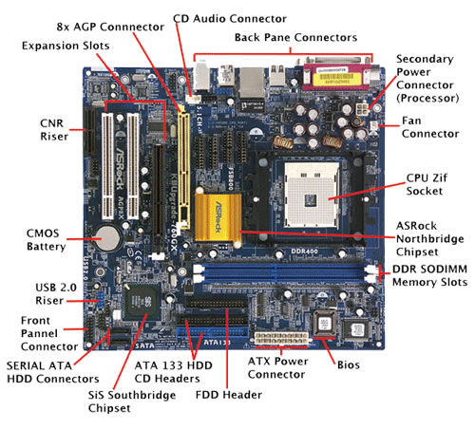

On 14th October 2021 in lab, we divided ourselves into groups and following the pdf we were given on replacing a motherboard, we managed carefully remove the motherboard from the pc .we sketched layout of main components (ABOVE) and labeled them. The type of motherboard was (ATX MOTHERBOARD). According to our research it’s an ATX motherboard because:

* Integrated I/O port connectors
* Integrated PS/2 mouse connector
* Reduced drive bay interference
* Reduced expansion card interference
* Better power supply connector
* "Soft Power" support
* 3.3V power support
* Better air flow
* Improved upgradability

We also did some activities as follows:

Main difference between ATX & BTX

* ATX motherboard is predecessor of BTX designed to replace the earlier AT design. On the other hand, BTX motherboard is the newer version of ATX and it is designed so as to maximize the cooling of the processor used.
* The full form of ATX is the Advanced Technology eXtended. On the other hand, the full form of BTX is Balanced Technology eXtended.
* The flow of air is less in the design of ATX motherboard. On the other hand, the flow of air is more in the design of BTX motherboard.
* The IO port is situated on the top of an ATX board. On the other hand, the IO port is situated on the bottom of a BTX board.
* The use of ATX motherboard is more in the desktops. On the other hand, the use of BTX motherboard is rarely seen in desktops.
* The ATX motherboard does not require a special arrangement in the design of motherboard components so as to maximize the cooling. On the other hand, the BTX motherboard requires a special arrangement in the design of motherboard components so as to maximize the cooling.

**MAIN DIFERENCE BETWEEN ATX AND MINI-ITX.**

The difference between ATX and ITX is that **ATX has a standard size and is intended for use in standard PCs**, have a high number of PCI slots and higher RAM capacity while an ITX is smaller than the standard size and are used in compact PCs usually meant for traveling.